Name ______________________________ HOMEWORK Oct. 4-8
Module 2 Week 3
Put your initials by each night that your child practiced the following:
____Tuesday ____Thursday
*Nightly Homework*
1. Count numbers 1-25.
2. Practice assigned Sight Word list in red reading folder.
3. Say the following letter names and sounds.
Mm Ss Tt Bb Aa Nn Dd

Tuesday: Write three words that are in the -at word family.
_____________ ______________ ______________

Read it. Trace it. Write it.
man man _________
no no _________
is is _________

Thursday- Draw pictures of words that start with:

Nn Dd

Say the word, count the syllables, and color the number you hear.

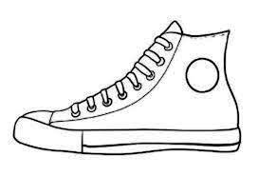
4
3
2
1
4
1
3
2
4
3
2
1

4
4
4
3
3
3
2
2
2
1
1
1

Start Right Reader

Words to know
is man no
Go, Tad
“Tad, see the ball?
Go to the ball!”
“A nest? No, Tad.
Go to the ball!”
“A doll? No, Tad!
Go to the ball!”
“A net? 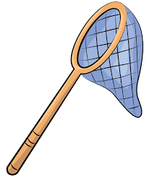 No, Tad!”
“See the man, Tad?
The ball is by the man.”
“Tad!”

